COMP2113 Programming Technologies /

ENGG1340 Computer Programming II

**Module 6 Checkpoint Exercise**

Name: Cheng Ho Ming

University ID: 3036216734

**Instructions:**

For each single question or each group of questions in the Checkpoint exercise, please type your answer right after the question in this Word document.

**Checkpoint 6.1 (Please submit your answer to Moodle)**

There may be error(s) in the following statements. Correct the error(s) if any, if no error, please write “no error”.

a) double a [1] [2] = {{2,3}, {3,2}};

b) double b [1] [2] = {{3}};

b) char b[1000] = "string";

Ans:

a) double a [2] [2] = {{2,3}, {3,2}};

b) no error

c) no error

**Checkpoint 6.2 (Please submit your answer to Moodle)**

Consider the following code:

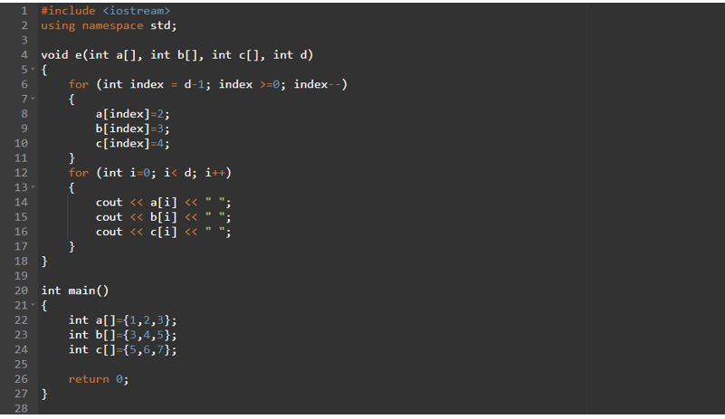

a) What is the output if the above program is executed? (if no output, please write “no output”)

b) What is the output if e(a,b,c,3); is added to line 25? (if no output, please write “no output”)

c) What is the output if e(a,b,c,5); is added to line 25? (if no output, please write “no output”)

Ans:

1. no output
2. 2 3 4 2 3 4 2 3 4
3. The result is undeterminable as e(a,b,c,5) will cause an array out of bound error.

**Checkpoint 6.3 (Please submit your answer to Moodle)**

Assume a 3D double array x is defined as

double x[2][2][3] = { { {3, 4, 2}, {0, -3, 9} }, { {13, 4, 56}, {5, 9, 3}}}; Write a program that would find the maximum and minimum values in this 2-by-2-by-3 double array x. Print the maximum and minimum value after they are found.

#include <iostream>

using namespace std;

int main(){

    double x[2][2][3] = { { {3, 4, 2}, {0, -3, 9} }, { {13, 4, 56}, {5, 9, 3}}};

    int max_value, min_value = x[0][0][0];

    for (int i = 0; i < 2; i++){

        for (int j = 0; j < 2; j++){

            for (int k = 0; k < 3; k++){

                if (x[i][j][k] > max_value){

                    max_value = x[i][j][k];

                }

                if (x[i][j][k] < min_value){

                    min_value = x[i][j][k];

                }

            }

        }

    }

    cout << max_value << " " << min_value << endl;

}